PHAC-McMaster model 20210903

Document

Public Health Agency of Canada. Update on COVID-19 in Canada: Epidemiology and Modelling, September 3, 2021. <https://www.canada.ca/content/dam/phac-aspc/documents/services/diseases-maladies/coronavirus-disease-covid-19/epidemiological-economic-research-data/update-covid-19-canada-epidemiology-modelling-20210903-en.pdf>

Page 6

Longer range forecast still showing strong resurgence trajectory, but strengthening measures to reduce spread could slow acceleration

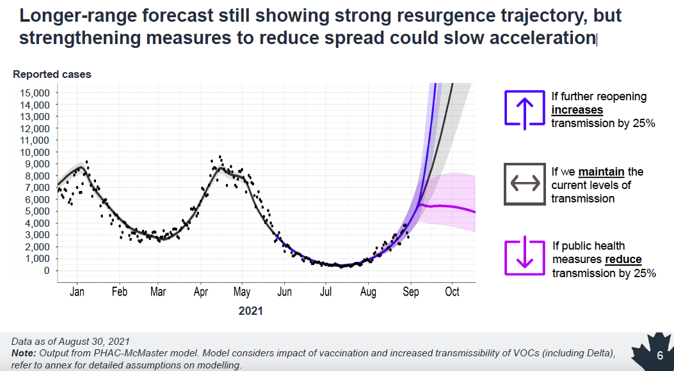

Data as of August 30, 2021

Note: Output from PHAC McMaster model. Model considers impact of vaccination and increased transmissibility of VOCs (including Delta), refer to annex for detailed assumptions on modelling.